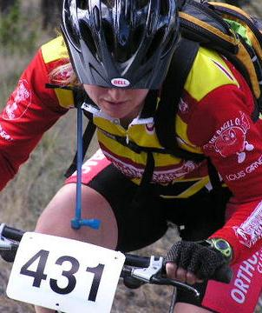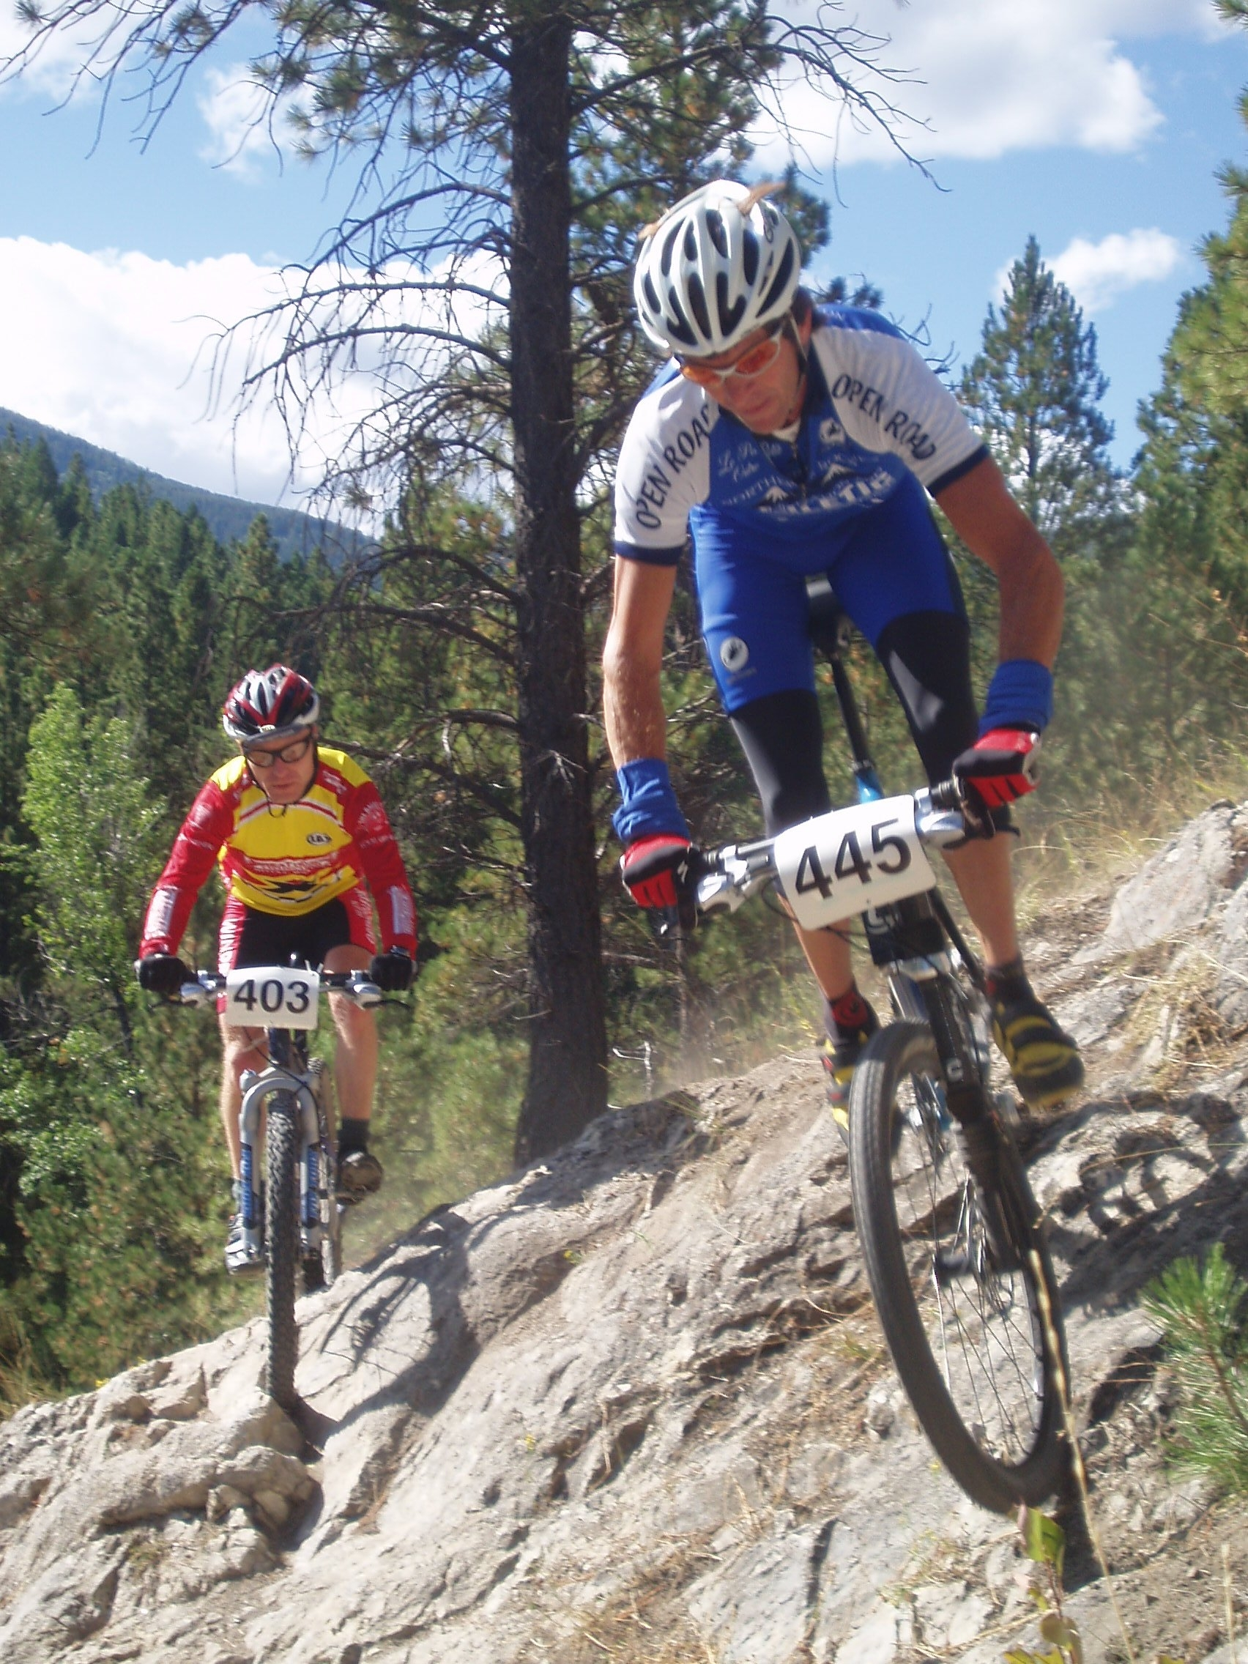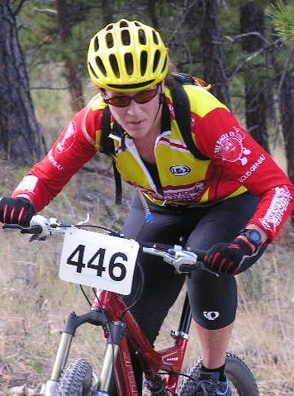
WERKS
Mountain Bike Race
Helena MT
Sunday September 10
$500 Dollars in giveaways for all finishers and cash for winning experts
State M.O.R.S. Championship
Same great south hills cross country course
4.5 miles of prime Helena trails 70% single track

Race Registration will start at 9AM, Racing starts at 11AM
Beginner 2 laps
Sport and Single speed 3 laps
Experts 5 laps

Entry fee is $20 + NORBA License
$15 for students + license

The start / finish area will be at the Davis St. Trail head,
2 miles south of the Broadway & Davis intersection.

Sponsored by
Great Divide Cycling Team
Great Divide Cyclery, Windbag Saloon, Taco del sol,
Blackfoot River Brewery, Bagel Co

For more info contact
Trever Brandt
Tabmt@juno.com

